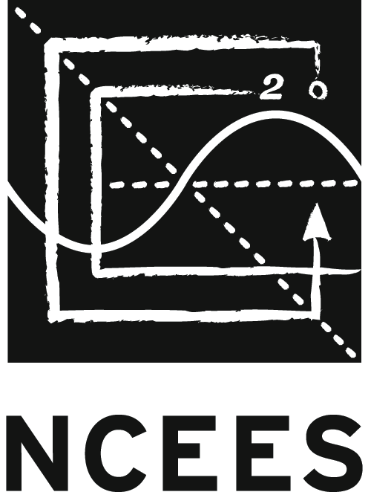
Adopted by the
NCEES Board of Directors August 2012

Revised February 2014
StRategic Plan

CONTENTS

1 Background

2 10–30 Year Planning Horizon
Core Ideology
–Core Purpose of NCEES
–Core Values of NCEES

3 Envisioned Future
BHAG (Big Hairy Audacious Goal)
Vivid Description

4 5–10 Year Planning Horizon
Environment Factors
Mega Issues

7 3–5 Year Planning Horizon
Goals, Objectives, and Metrics

14 Appendix

Background
In September 2011, the NCEES board of directors, working in concert with NCEES senior staff, began developing a new strategic plan for the organization. Meeting at a retreat at NCEES headquarters in Clemson, S.C., the group focused primarily on the strategic environment, mapped the key trends that would affect NCEES in the future, identified barriers to continued success, and determined which existing NCEES initiatives are responsive to the changing environment.

Between the September retreat and subsequent board of directors meeting in November, the environmental trends that had been identified were tested with member boards through an online survey. The results of that survey helped guide the discussion at the November meeting, where purpose, values, vision, and goals were addressed.

Following the November meeting, two interim steps occurred:
1. A series of six one-on-one interviews with executive directors of affiliate societies was conducted, and the results were shared with the board of directors prior to its February 2012 meeting.
2. In two iterative surveys, board members were asked to identify and then rank the conditions that could make each goal critical for NCEES to pursue. The results of that ranking were used in February as the basis for developing objectives.

In the final planning meeting in February, the board of directors confirmed the purpose, clarified the vision for NCEES, and recrafted the draft goals. This resulted in a set of six goals, as well as creating priority objectives and possible metrics for each goal. In March, consultant Cate Bower met with NCEES senior staff in Clemson to refine objectives, create strategies for the first 12–18 months, and finalize recommended strategies. The staff then did a final review of the product of that session. The entire plan, with those additions, was provided to the board of directors for approval. The board voted to adopt this strategic plan at its August 2012 meeting.

The model used in developing this plan is based on the four planning horizons approach to strategic planning illustrated on the next page.

10–30 YEAR PLANNING HORIZON

Core Ideology and Envisioned Future

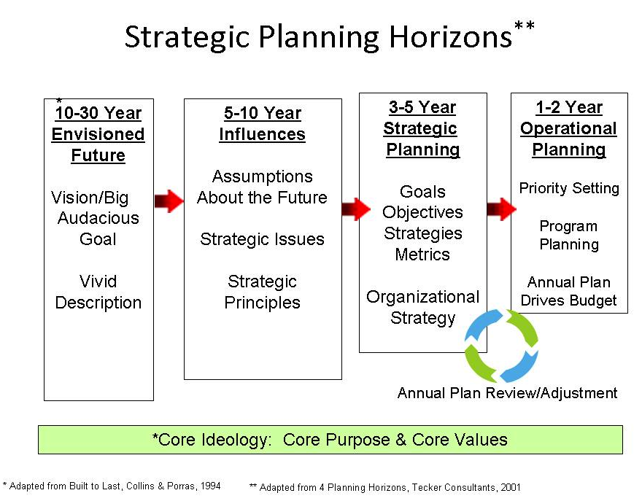

CORE IDEOLOGY
Core ideology describes an organization’s consistent identity that transcends all changes related to its relevant environment. Core ideology consists of two notions: core purpose—the organization’s reason for being—and core values—essential and enduring principles that guide an organization.

Core Purpose of NCEES
The purpose of NCEES is to advance licensure for engineers and surveyors in order to protect the health, safety, and welfare of the public.

Core Values of NCEES
Importance of demonstrating competency
Ensuring the highest quality in everything we do
Defined standards ensure public safety
Active engagement of key stakeholders in our work
Leadership in licensure

ENVISIONED FUTURE
Envisioned future conveys concrete, but yet unrealized, vision for the organization. It consists of a big hairy audacious goal—a clear and compelling catalyst that serves as a focal point for effort—and a vivid description—a vibrant and engaging description of what it will be like to achieve the big audacious goal.

Big Hairy Audacious Goal (BHAG)
NCEES leads in the development and establishment of standards of licensure that protect the public, resulting in licensure and mobility for all professionals in engineering and surveying.

Vivid Description
What constitutes success if we achieve the vision?

What would we like to see happen?
- Engineering is the most respected profession.
- There is a more robust accreditation system and more qualified engineers.
- The U.S. engineering and surveying licensure system is the global model for licensure and viewed as the gold standard internationally.
- NCEES becomes clearinghouse for all foreign applicants for licensure in the United States and licensure of U.S. engineers and surveyors in foreign countries.
- The industrial exemption is eliminated.
- NCEES standards are broadly adopted internationally.

What would NCEES look like?
- Simpler to all
- Transparent
- Culturally diverse
- More nimble
- Larger and providing more services
- Recognized resource

What will NCEES feel like to stakeholders?
- NCEES is the best of the best.
- NCEES is an international organization.
- The exam process is totally an NCEES process.
- Member boards have the option of shifting the application process to NCEES and could instead concentrate on licensure, enforcement issues, safety, etc., if they so choose.
- Stakeholders have the utmost confidence in the organization.

What will NCEES have achieved?
- Higher degree of protection of the worldwide public health, safety, and welfare
- Uniformity in recognition of licensure credential
- Absolute/full comity and mobility of practice
- Enhanced worldwide public protection—fewer catastrophic events

5–10 YEAR PLANNING HORIZON

Building Foresight: Environmental Factors

Assumptions about the relevant future environment will help NCEES purposefully update its strategic plan on an annual basis. Goals are a necessary foundation for successful strategic planning. Goals are based, in part, on anticipation of the possible future. NCEES’ projected future environment is described in this section. An annual review of these assumptions will help NCEES budget the necessary funds to ensure the ongoing relevance of its strategy. When conditions change, the strategy will need to be adjusted. The assumptions, which appear here, are those deemed to be most critical to the NCEES budget within the next 3–5 years.

Working together, the group created a visual mind map of the emerging trends and issues that might have an impact of NCEES and those it serves over the life of the plan. The picture of the mind map appears below.

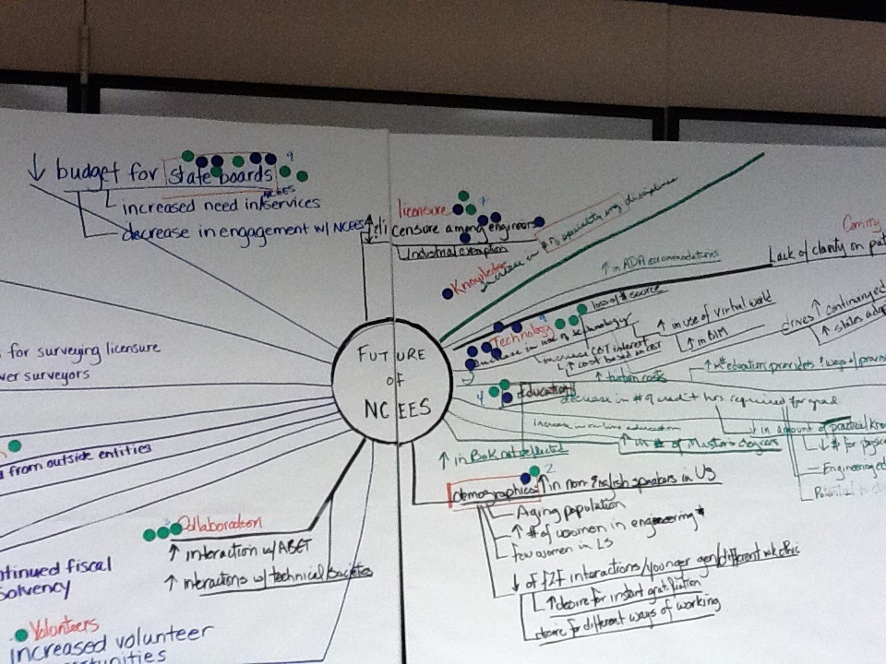

5–10 YEAR PLANNING HORIZON: ENVIRONMENTAL FACTORS
These are the key areas identified along with frequency counts of the relative importance of the identified trends. Contradictory trends were permitted.

State boards (9)
- Declining budgets for states
- Increased need for NCEES services
- Decreased participation in NCEES

Technology (9)
- Increase in use of technology
- Increased computer-based testing (CBT) interest
- Increased costs based on CBT
- Loss of revenue source
- Increase in use of virtual world
- Increase in building information modeling (BIM)
- Drives increased continuing education
- Increase in number of states adopting continuing professional competency (CPC) requirements

Financial (9)
- Continued financial solvency

International competition (7)
- Increased international competition
- Insufficient number of U.S. engineering graduates
- Increased interest in foreign exam administration

Comity (7)
- Lack of consistency on path to comity/licensure
- Increased interest in Records program

Engineering Licensure (7)
- Increased/decreased number of engineering candidates for licensure
- Industrial exemption

Surveying Licensure (5)
- Decline in number of surveying candidates for licensure
- Aging population
- Increase in education requirements for surveying licensure
- Increase in technology results in fewer surveyors

Education (4)
- Decline in number of credit hours required for graduation
- Decline in amount of practical knowledge
- Decline in amount of money for physical facilities at universities
- Unclear impact of the engineering education initiative
- Increased tuition costs
- Increase in number of education providers and ways of providing
- Increase in Body of Knowledge
- Increase in amount of online education
- Increase in number of master’s degrees

Collaboration (3)
- Increase interaction with ABET
- Increase interactions with technical societies

Demographics (2)
- Increase in non-English speakers
- Increase in number of women in engineering
- Few women in surveying
- Decline in face-to-face interactions
- Younger generation with different work ethic
- Increased desire for instant gratification
- Desire for different ways of working

Other areas
- Outreach (1)
- Globalization
- Testing (1)
- Sustainability
- Certification
- Volunteers (1)
- Public (3)

5–10 YEAR PLANNING HORIZON: MEGA ISSUES
Mega issues are issues of strategic importance that represent challenges the organization will need to face in defining the ultimate direction of its long-range plan. These issues represent potential impediments to achievement of the envisioned future and form a basis for dialogue about the choices facing the organization. These questions can also serve as an ongoing menu of strategic issues that the board of directors and senior staff can use—in a knowledge-based approach to gathering insights relative to NCEES’ strategic position and directional choices—to create regular opportunities for strategic dialogue about the issues facing the organization and its member boards.

How NCEES Operates
- Why do we do things the way we do, and how do we shift the mindset to be more open to new ideas?
- What are the limitations of the available resources, and how do we ensure we have sufficient resources to accomplish our plan? What resources will we need to fulfill the plan?
- How do we avoid overcomplicating solutions to complex problems?
- How can governance facilitate active participation by all member boards?

Licensure
- How do we impact state regulations and laws that are barriers to licensure and effectively work within the limitations those pose? (industrial exemption)
- How do we build consensus around licensure? How do we manage the differing objectives of differing engineering groups?
- How do we keep/get the engineering societies and industry to value the importance of licensure?
- How do we get students and faculty to value the importance of licensure? What are the barriers to getting people to take the FS, FE, PS, and PE exams?
- How do we get greater standardization (comity) across states?

Relationship with Member Boards
- How do we better deal with the complexities/inconsistencies posed by the differing structures of our member boards?
- How do we compensate for the high degree of turnover among members of member boards?

Communications
- How do we communicate more effectively with our constituents?
- How do we help candidates better understand the differences between the work of NCEES and the work of the licensure boards?

3–5 YEAR PLANNING HORIZON

Outcome-Focused Goals, Objectives, and Metrics

The following thinking represents the organization’s goals for the next 3–5 years. These goals are outcome-oriented statements that define what will constitute NCEES’ future success. The achievement of each goal will move the organization toward the realization of its envisioned future. The objectives reflect the broad range of directions that will be undertaken to change existing conditions in order to achieve the goal.

Standards
NCEES is the recognized leader in developing and establishing licensure standards that serve to protect the public, are used by all member boards, and lead to increased mobility.

International
The NCEES examinations will increasingly be used outside the United States as an outcomes assessment tool and to assist in determining minimum competency.

Public Awareness
The general public has greater understanding that engineering and surveying licensure are essential to public health, safety, and welfare.

Growth of Licensure
The demonstrated value of licensure will result in continued growth in the number of licensed engineers and surveyors.

Organizational Governance
NCEES’ governance processes and structures will facilitate active engagement of all member boards.

Education
Education standards for entry into professional practice and for continued licensure will continually evolve to reflect minimum requirements for the protection of the public.

STANDARDS GOAL
NCEES is the recognized leader in developing and establishing licensure standards that serve to protect the public, are used by all member boards, and lead to increased mobility.

Priority Objective
1. Increase uniformity among member boards.

Proposed Strategies
1. Expand and maximize the use of My NCEES to facilitate uniformity among member boards.

- High priority
2. Create a committee/task force to promote the adoption of the NCEES Model Law
for mobility purposes High priority
3. Benchmark common continuing education requirements by all member boards, and develop an action plan to promote the adoption of common standards for continuing education requirements.
4. Serve as a repository of information on the subject of engineering and surveying licensure both domestically and internationally.
5. Provide for a system whereby NCEES maintains the pertinent credentials for licensed individuals to include exam results, the evaluation of education, Council Record information, etc., which is available electronically to all member boards to better facilitate mobility.

Draft Metrics
- Ten additional member boards will be using the new examinee management system (EMS) for application and approval process within five years.
- NCEES continuing education guidelines will be adopted and implemented by 10 percent of member boards within five years.
- All NCEES member boards will be using the NCEES online examination verification system within three years.

INTERNATIONAL GOAL
The NCEES examinations will increasingly be used outside the United States as an outcomes assessment tool and to assist in determining minimum competency.

Priority Objective

1. Serve as a conduit to NCEES member boards in matters relating to international licensure/comity matters.
- Educate member boards on the need and value of international comity
- Increase NCEES’ participation in the activities of international based engineering licensure organizations

Secondary Objective

1. Promote the U.S. system and the use of NCEES exams as the de facto model for the licensure of engineers.
2. Promote the use of the NCEES FE exam as an outcomes assessment tool to all foreign programs that attain EAC/ABET status.

Draft Metrics

- Secure Council endorsement of approval process within two years.
- Workshops on international licensure are conducted at NCEES annual meeting.
- NCEES pursues leadership role in the International Engineering Alliance.
- NCEES exams are offered in an additional five foreign countries within three years.

PUBLIC AWARENESS GOAL
The general public has a greater understanding that engineering and surveying licensure are essential to public health, safety, and welfare.

Priority Objective
1. Increase awareness of licensure and the value of licensure to the public.

Proposed Strategies

. High priority
1.1 Official statement/action from Council that affirms our ability to promote value of
licensure to all audiences (policy/position statement).
1.2 Review and evaluate the K-12 initiatives in relation to public awareness. High priority
1.3 Create crisis communications/disaster response plan (through member board level).
1.4 Coordinate a K–12 event in concert with the 2014 NCEES annual meeting.
1.5 Develop and implement plan to sponsor grants for Engineering Without Borders projects.
1.6 Establish a Young Professionals program to promote the value of licensure and to provide the opportunity to receive feedback concerning the licensure process.

Secondary Objective
2. Educate public on roles of professional engineers and surveyors.
- Explore additional opportunities to promote engineering, surveying and licensure to the audiences defined in the integrated marketing plan, i.e. DiscoverE, Family Day, and National Surveyors Week.
- Evaluate the potential for a national media campaign to promote the value of engineering and surveying licensure.

Draft Metric
- A benchmark from which to develop quantifiable measures of change is established.
- Crisis communication/disaster response plan is developed, approved, and implemented in two years.
- Parameters for a Young Professionals program are established and funding is authorized within one year.
- Grant program for Engineers Without Borders is established within one year, and funding is authorized for continued sponsorship by NCEES.

GROWTH OF LICENSURE GOAL
The demonstrated value of licensure will result in continued growth in the number of licensed engineers and surveyors.

Priority Objective
1. Increase academia, student, corporate, and government understanding of the value of employing licensed engineers and surveyors consider actions that can be pursued by the Council to mitigate the declining population of candidates taking the NCEES surveying examinations

Proposed Strategies
Academia/Students

1.1 Explore outreach to deans of engineering and surveying programs to help them understand importance of licensure and their support of the same.

1.2 Revisit previous task force study and recommendations regarding licensure for faculty, including nontraditional paths to licensure for faculty.
1.3 Utilize the planned Young Professionals program to better understand impediments to licensure and the motivation for individuals to pursue licensure.

Corporate/Government

1.4 Consider USGBC model as a template to build success.
1.5 Explore alternative methods of measuring experience in order to qualify for licensure.
1.6 Work to dispel the myths about who can and cannot qualify for licensure.
1.7 Seize opportunities to promote value of licensure to public.
1.12 Create crisis/disaster communications plan (through member boards level).
1.13 Monitor key areas through options like Google Analytics.

Secondary Objectives
2. Develop partnership with professional societies to decrease number of industrial exemptions.
3. Increase number of licensed faculty.
4. Ensure that graduating engineers and surveyors understand the value of licensure.
5. Increase the exposure of students to professional practice.
6. Promote to member boards to adopt change to Model Law decoupling experience as a requirement to take the PE exam.

Draft Metrics
- Establish benchmark information for academia, student, corporate, and government audiences.

- Within three years, 25 percent of NCEES member boards have amended their requirements to decouple experience as a condition for taking the PE exam.
- The integrated marketing plan is amended to incorporate feedback from the Young Professionals program and to include additional outreach efforts to promote licensure to engineering and surveying faculty.

ORGANIZATIONAL GOVERNANCE GOAL
NCEES’ governance processes and structures will facilitate active engagement of all member boards.

Priority Objectives
1. Increase leadership identification and development opportunities.

Proposed Strategies
1.1 Have leadership personally contact new members; conduct targeted communications.
1.2 Assign mentors at zone meetings and annual meetings.

1.4 Identify and track leaders; educate member boards about the leadership process.
1.5 Provide synopsis of paths to leadership to provide a clearer understanding for people interested in pursuing leadership positions.

2. Maintain financial support of delegates to attend Council meetings.

Proposed Strategy
2.1 Continue to provide funding as approved in the budget process for members to attend NCEES meetings.

Secondary Objectives
3. Reduce length of time to effect changes.

Medium+ priority

4. Increase participation of members and member boards.

Proposed Strategies

4.1 Explore opportunities to engage younger professionals in the work of NCEES.
4.2 Investigate methods to increase engagement by member boards at NCEES meetings.
4.3 Utilize current NCEES leadership to engage and interact with less engaged member boards.

Draft Metrics
- Increase the number of responses received to committee preference survey by 10 percent within two years.

- Attendance at NCEES interim and annual meetings is increased by 10 percent.
EDUCATION GOAL
Education standards for entry into professional practice and for continued licensure will continually evolve to reflect minimum requirements for the protection of the public.

Priority Objective
1. Increase educational requirements for initial licensure.

Proposed Strategies
1.1 Promote recommendations of the Engineering Education Task Force
appendix/white paper. High+ priority
1.2 Use the work of the Engineering Education Task Force on identified audiences
as launch pad. Low- priority
1.3 Use the Participating Organizations Liaison Council to have more dialogue about
this with other societies. Medium priority

Secondary Objectives
2. Increase NCEES’ ability to anticipate and define future educational needs.

Proposed Strategies
2.1 Continue participation in and engagement with ABET. High priority
2.2 Establish a way to be notified when member boards change education
requirements (board profile). Medium priority

3. Routinely review and update the NCEES Continuing Professional Competency Guidelines.

Proposed Strategies
3.1 Charge Education Committee with annually reviewing the CPC Guidelines
(board profile). High priority
3.2 Look at continuing education across all member boards, and develop a recommendation for a consistent requirement on minimum required continuing education.
3.3 Develop and implement a plan for promotion and adoption of consistent continuing education requirements.
3.4 Do an online survey to assess priorities.

Draft Metrics
- Increase in number of boards that have adopted additional education requirements
- Increase in number of boards that endorse the additional education requirements
- Nomination of NCEES representatives to ABET board and commissions annually

APPENDIX

STANDARDS GOAL
NCEES is the recognized leader in developing and establishing licensure standards that serve to protect the public, are used by all member boards, and lead to increased mobility.

Priority Objective
1. Increase uniformity among member boards.

Existing Programs that Support this Objective
- Create board profile to identify boards’ processes and procedures, and display comparisons between boards to highlight similarities/differences (IT, Corporate Communications)
- Offer software applications to member boards that provide them with options to facilitate standard processes among boards (Records, Credentials, exam registration, board profile, enforcement, exams, My NCEES)
- Develop and maintain standards for administering exams (Exam Publications, Compliance and Security, Exam Administration Services, Exam Development)
- Produce (edit/print) exams and study materials. (Exam Publications, Exam Development)
- Increase uniformity among member boards by providing score results and diagnostics to boards and testing services (IT, Exam Development, Exam Scoring)
- Apply financial policies and procedures. (Office of the Executive Director, Finance)
- Update of Model Law/Rules (per UPLG) after annual meeting; communication of major changes via direct mail and email to MBAs, news releases, and Licensure Exchange article major changes (Office of the Executive Director, Corporate Communications)
- Create standard approval application; exam authorization/seat cards (Exam Administration Services); special accommodations process for boards that use Exam Administration Services (Human Resources)
- Facilitate opportunities at meetings for member board discussion on issues related to uniformity (Office of the Executive Director, Meetings and Outreach Logistics)
- Ensure consistency (legal and process) of special accommodations for all NCEES exams (HR)
- All boards accept Model Law Engineer, Model Law Surveyor, and Model Law Structural Engineer designations (Records)
- Require examinees to review and acknowledge NCEES Candidate Agreement (Office of the Executive Director, Exam Pubs, Compliance and Security, Exam Administration Services, Exam Development)
- Produce and distribute Licensure Exchange newsletter, which shares NCEES activities, board activities, member board information, etc. (Corporate Communications)

INTERNATIONAL GOAL
The NCEES examinations will increasingly be used outside the United States as an outcomes assessment tool and to determine minimum competency.

Primary Objective
1. Codify the process for responding to international requests.

Existing Programs That Support This Objective
- Making sure international sites adhere to NCEES policies and procedures (Office of the Executive Director, Exam Administration Services)
- Existing policy defines circumstances in which exams can be offered at international sites (current policy lacks detail) (Office of the Executive Director, NCEES Board of Directors, Council)
- FE as an outcomes assessment tool (possibly expand this current messaging in some way to include the international audience) (Public Affairs, Exams)

Secondary Objective
2. Increase NCEES’ capacity and consistency in responding to diverse requests for licensing information, and prepare an NCEES model for licensure to provide to interested parties.

Existing Programs That Support This Objective
- Answering feedback forms/explaining licensure to non-U.S. candidates (Credentials Evaluations)
- Ongoing survey to develop matrix of licensure/certification requirements for other countries as a tool for member boards and public (Office of the Executive Director, Corporate Communications)
- FE as an outcomes assessment tool (possibly expand this current messaging in some way to include the international audience) (Office of the Executive Director, Public Affairs, Exam Development)
- NCEES Candidate Agreement (Office of the Executive Director, Exam Publications, Compliance and Security, Exam Administration Services, Exam Development)
- Copyright/permissions/protection of intellectual property (Exam Publications)
- Requests come through executive director so that there is some uniformity (Office of the Executive Director, Exam Administration Services)
- Develop and maintain standards for administering exams (Exam Pubs, Exam Development, Security/Compliance, Exam Administration Services)

PUBLIC AWARENESS GOAL
The general public has a greater understanding that engineering and surveying licensure are essential to public health, safety, and welfare.

Priority Objective
1. Increase awareness of licensure and the value of licensure to the public.

Existing Programs That Support This Objective
- EWeek plans to increase public awareness/value of licensed engineers. (Office of the Executive Director, Public Affairs)
- K-12 initiatives (EWeek, MathCounts, Trigstar, Future City competition) (NCEES Board, Office of the Executive Director, Public Affairs)
- Opinion pieces from leadership in response to issues (example, Gulf oil spill) (Office of the Executive Director, Corporate Communications)
- Produce and distribute Speakers Kits for licensed engineers and surveyors to use in public presentations regarding their profession (Corporate Communications)
- Maintain and suggest changes to website (IT, Corporate Communications, Public Affairs)
- Future City sponsorship (surveyor role) (NCEES Board, Office of the Executive Director, Public Affairs)
- NAE Convocation presentation (Office of the Executive Director)

Secondary Objective
2. Educate public on roles of professional engineers and surveyors.

GROWTH OF LICENSURE GOAL
The demonstrated value of licensure will result in continued growth in the number of licensed engineers and surveyors.

Priority Objective
1. Increase academia, student, corporate, and government understanding of the value of employing licensed engineers and surveyors.

Existing Programs That Support This Objective
- FE as an outcomes assessment tool (white paper online, direct mail, website, email blasts, ASEE, EDI, and ABET conferences) (OED, Public Affairs, Exam Development)
- Licensure Exchange, annual report (direct mail, brochures, website); study guides at shows and complimentary copy (Corporate Communications, Exam Publications)
- Conferences, presentations at American Society of Engineering Educators (Exam Development, Public Affairs, Exam Committee Volunteers)
- Engineering Education Award (brings message to public through individual projects/submissions)— direct mail, email blasts, ASEE, EDI, advertising (Public Affairs, Jury Panel)
- Outreach activities—Speakers Kit/Speakers Link (Meetings and Outreach Logistics); exhibits (Public Affairs, Meetings and Outreach Logistics, Records)
- Social media (Corporate Communications)
- K-12 initiatives (Public Affairs)
- Student competition sponsorships (Public Affairs)
- Advertising (Public Affairs)
- Brochures (Public Affairs)
- Webinars (Office of the Executive Director, Public Affairs)
- Website (Corporate Communications, IT)

Secondary Objectives
1. Decrease number of industrial exemptions.

Existing Programs That Support This Objective
- No programs in place now

2. Increase number of licensed faculty.

Existing Programs That Support This Objective
- Pending legislation by four NCEES member boards requiring professors who teach design level courses to be licensed (Office of the Executive Director)
- Model Law—Council passed language waiving the FE exam for Ph.D.s to encourage faculty licensure (Office of the Executive Director)

3. Ensure that graduating engineers and surveyors understand the value of licensure.

Existing Programs That Support This Objective
- Speakers Link/Kit; speaker requests (Meetings and Outreach Logistics)
- Presentations at conferences: NSBE, SWE, SHPE, ASCE, ACSM, etc. (Exam Development and Public Affairs)
- NCEES Engineering Award for Connecting Professional Practice and Education(Public Affairs)

4. Increase the exposure of students to professional practice.

Existing Programs That Support This Objective
- Engineer Education Award (Public Affairs)

ORGANIZATIONAL GOVERNANCE GOAL
NCEES’ governance processes and structures will facilitate active engagement of all member boards.

Priority Objectives
1. Increase leadership identification and development opportunities.

Existing Programs That Support This Objective
- Identify and track leaders; educate member boards in a process (Office of the Executive Director)
- Forthcoming recommendations from Leadership Taskforce (Office of the Executive Director)
- Communications audit for new members and MBAs with plans to improve (Public Affairs)
- New member orientation at annual meeting (Office of the Executive Director)

2. Maintain financial support of delegates to attend Council meetings.

Existing Programs That Support This Objective
- Increased funding options may be made available at NCEES board’s discretion for funding delegates (NCEES Board, Office of the Executive Director)
- Budget process (NCEES Board, Finance)
- Finance committee charges (Finance)
- Annual review of policies/procedures (Finance)
- Budget and plan Council meetings; help ensure content permits travel of member boards (Meetings and Outreach Logistics)
- Good financial management of Council funds (Finance)
- Current funding provided for designated delegates at annual meetings and zone meetings (Office of the Executive Director and Finance)

Secondary Objectives
3. Reduce length of time to effect changes.

Existing Programs That Support This Objective
- No programs in place

4. Increase participation of members and member boards.

Existing Programs That Support This Objective
- Provide and maintain online forum for discussion and information sharing pertaining to NCEES issues (IT, Member Boards)
- Provide collaboration software like Basecamp to get people in the conversation (IT)
- Increased use of technology to provide more effective communications, i.e., My NCEES, news releases, social media (Office of the Executive Director, IT, Corporate Communications)
- Provide opportunities for member boards to meet and help ensure content permits travel of member boards (NCEES Board, Office of the Executive Director, Meetings and Outreach Logistics)
- EWeek—member boards will participate in delivering presentations during EWeek (Council, Office of the Executive Director, Public Affairs)

EDUCATION GOAL
Education standards for entry into professional practice and for continued licensure will continually evolve to reflect minimum requirements for the protection of the public.

Priority Objective
1. Increase educational requirements for initial licensure.

Existing Programs That Support This Objective
- Increase already adopted by NCEES but not by member boards (Council)
- Model 2020 adopted, requiring master’s or other education elements (Council)

Secondary Objectives
2. Increase NCEES’ ability to anticipate and define future educational needs.

Existing Programs That Support This Objective
- Continuous review of NCEES Engineering Education Standard and NCEES Surveying Education Standard (Credentials Evaluations)

3. Routinely review and update the NCEES Continuing Professional Competency Guidelines.

Existing Programs That Support This Objective
- Review conducted by Education Task Force; review to become standard charge to Education Committee (NCEES Board of Directors, Office of the Executive Director)
- Ongoing discussions with NCARB and CLARB to collaborate (Office of the Executive Director)
- New Education Committee to work on continuing education issues (NCEES Board of Directors, Office of the Executive Director)

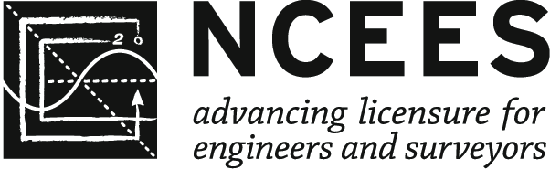

P.O. Box 1686, Clemson, SC 29633
ncees.org

